Screenshots:

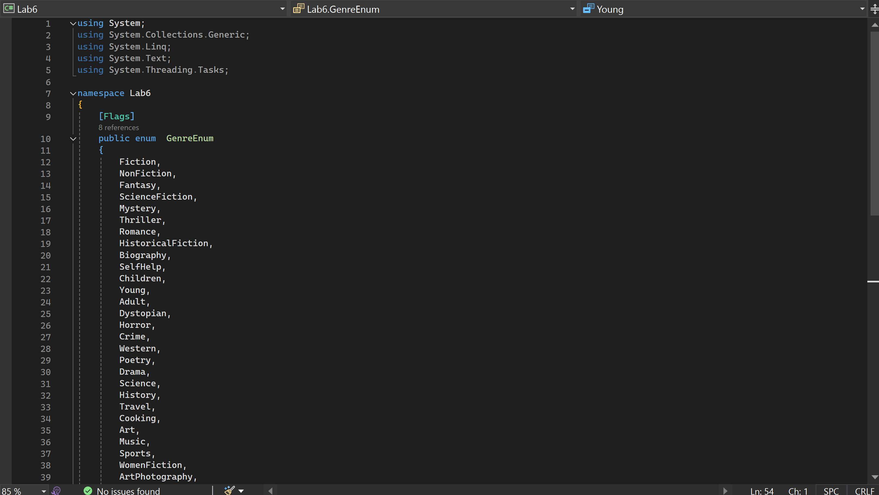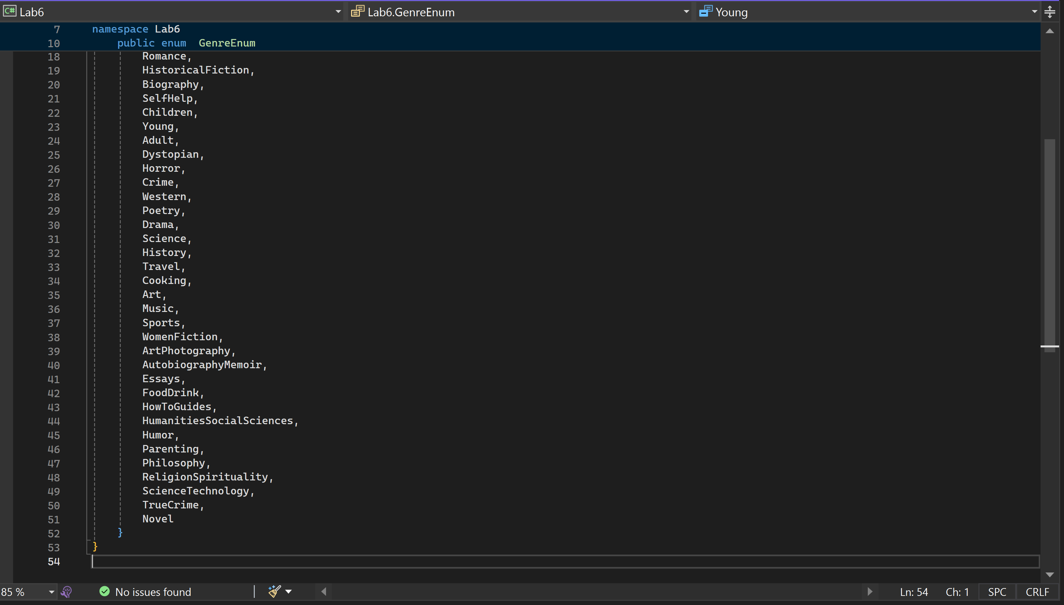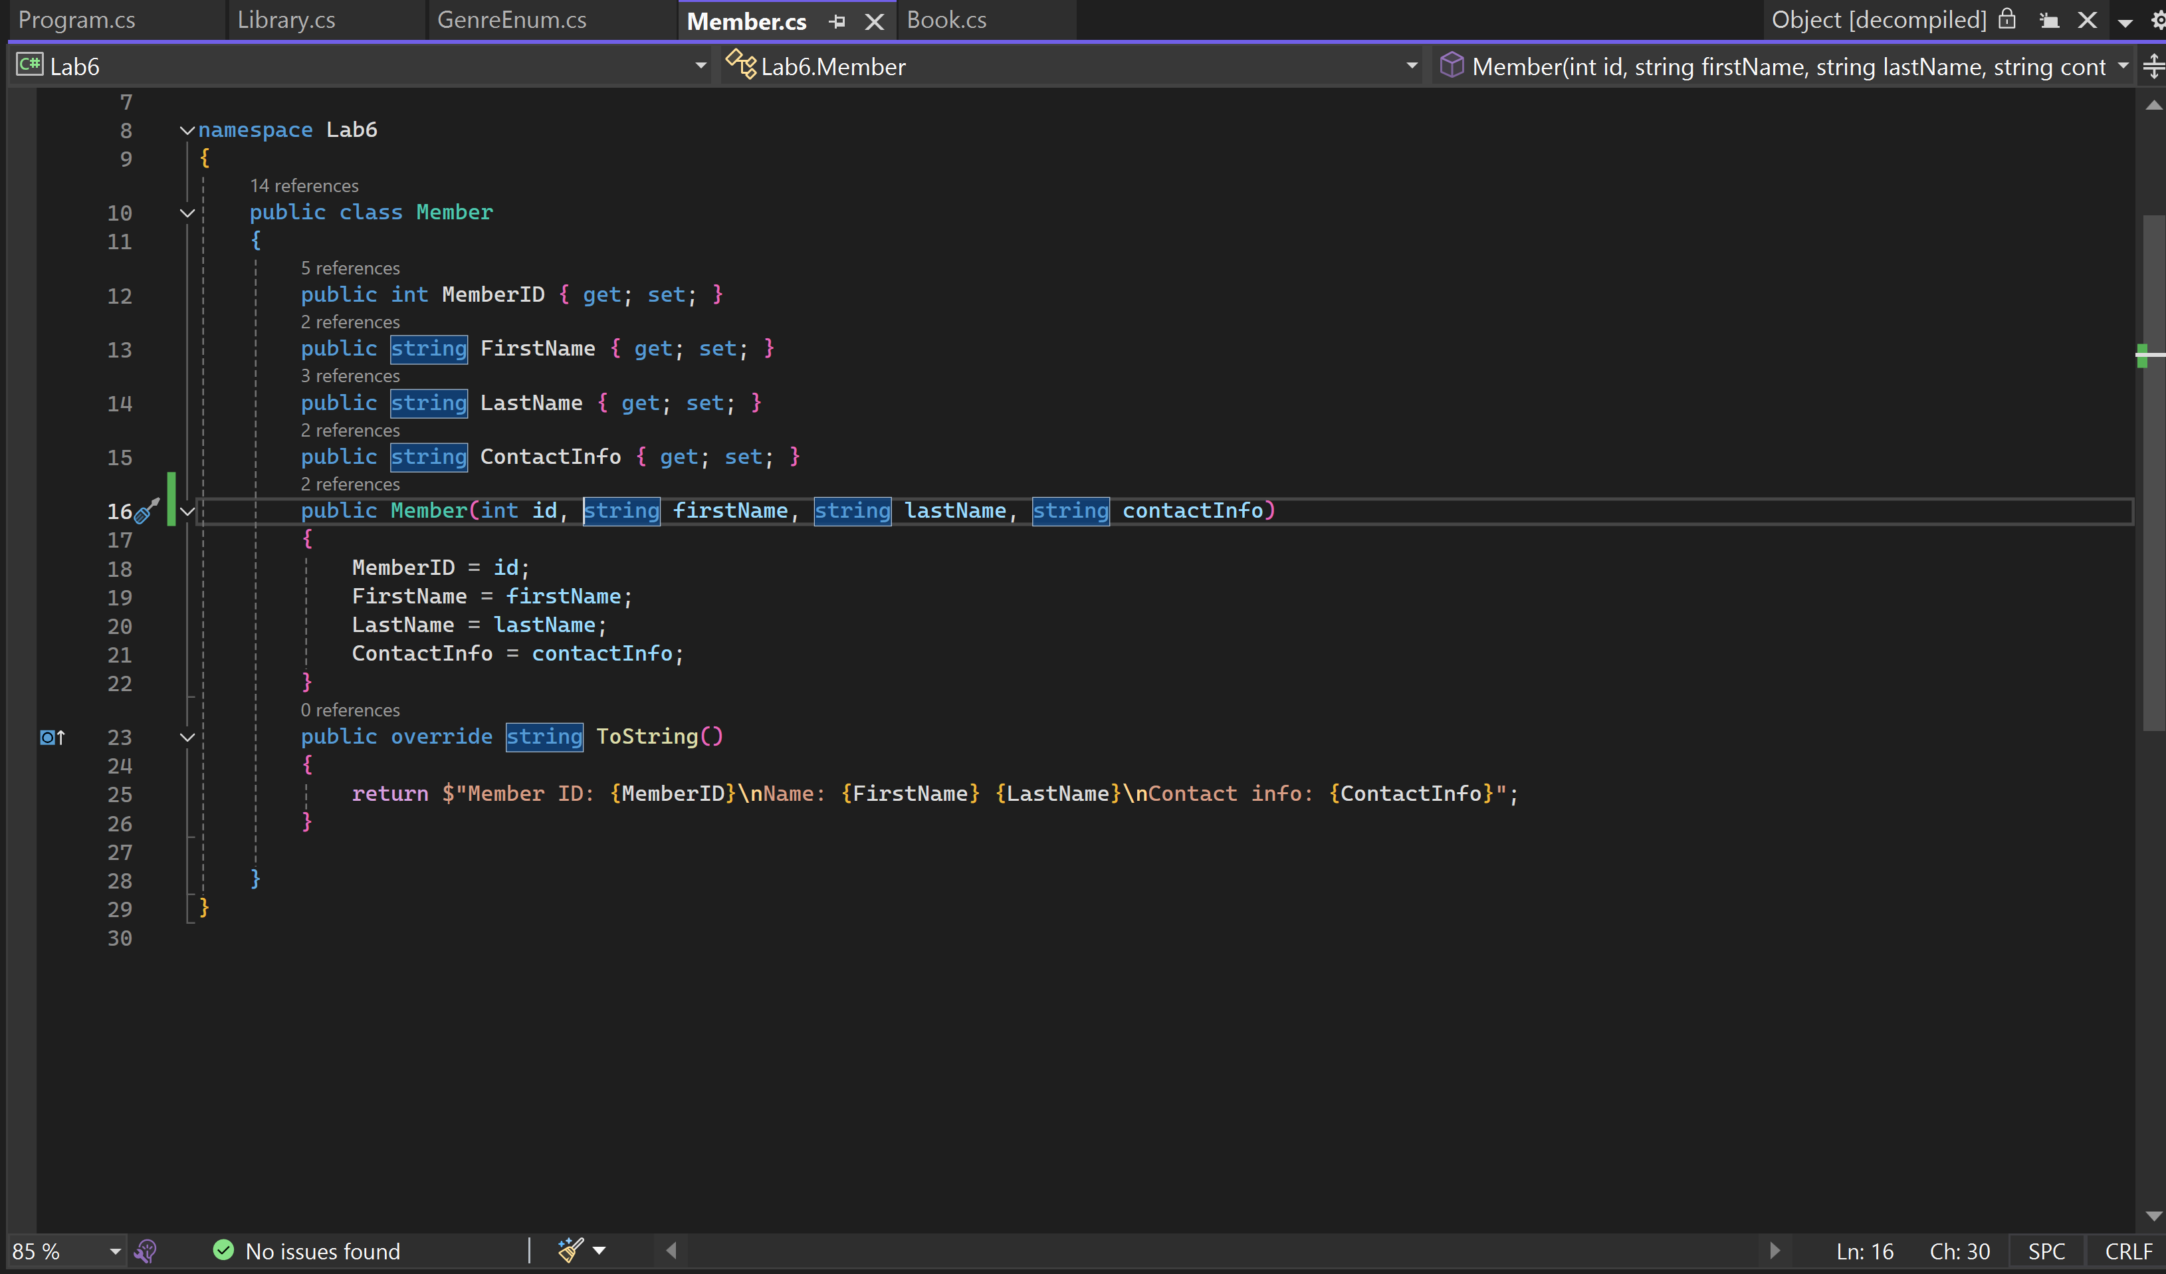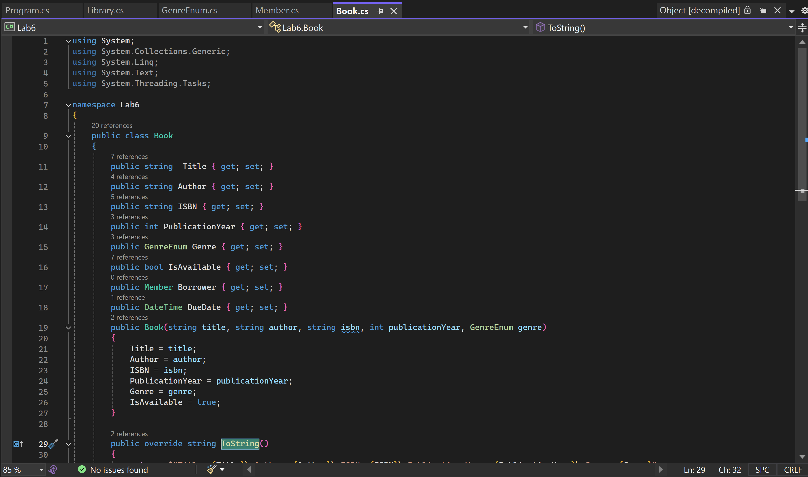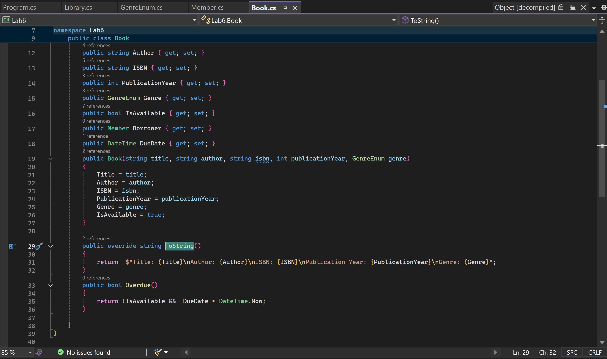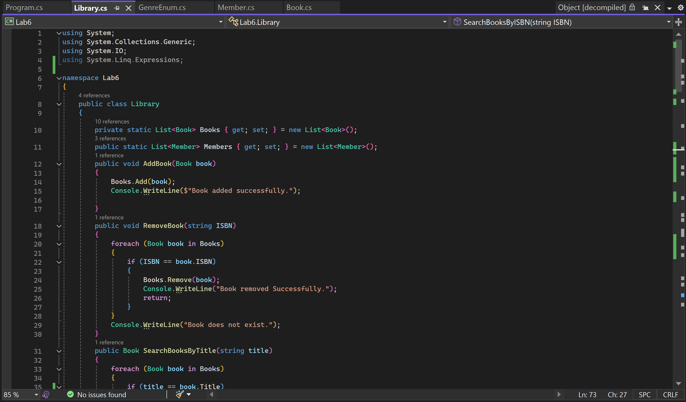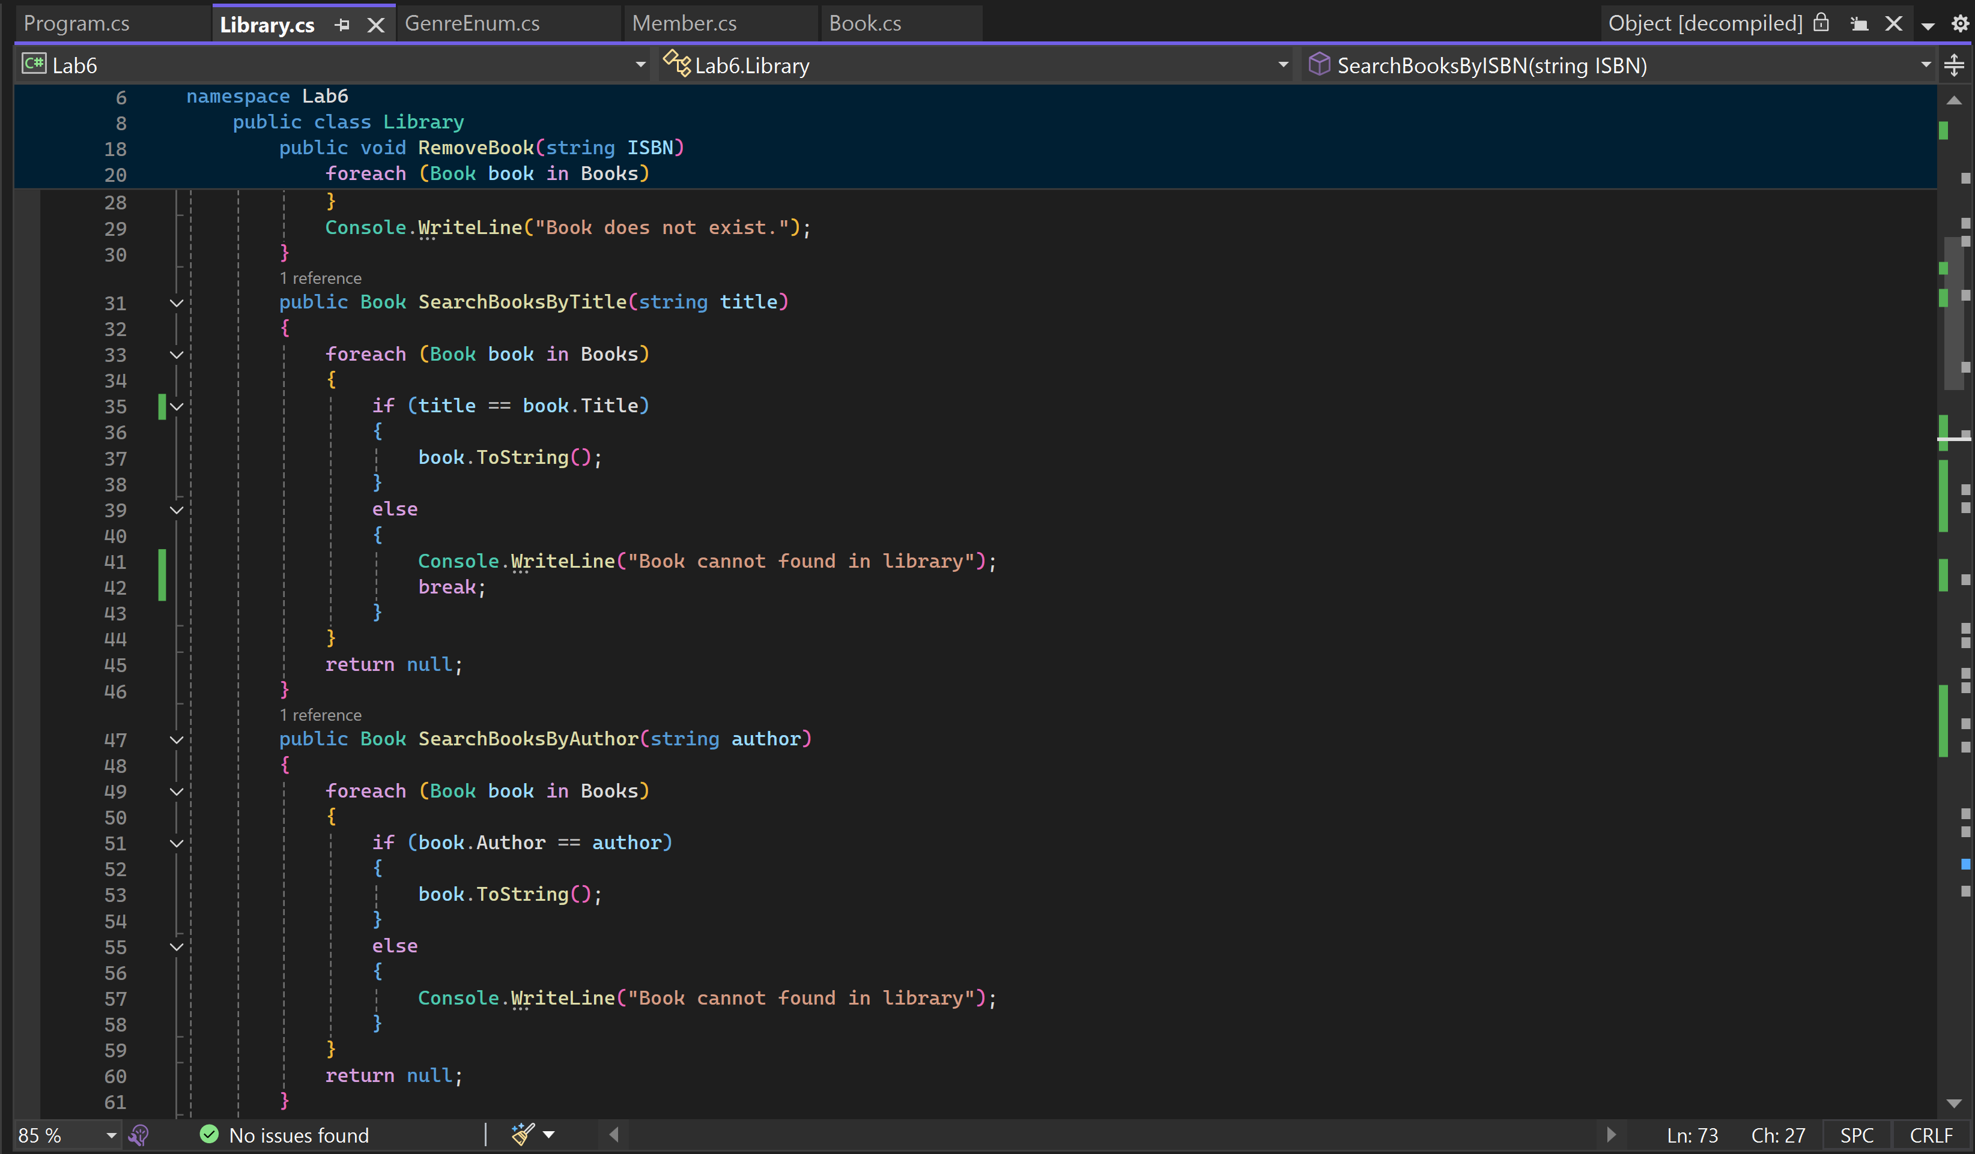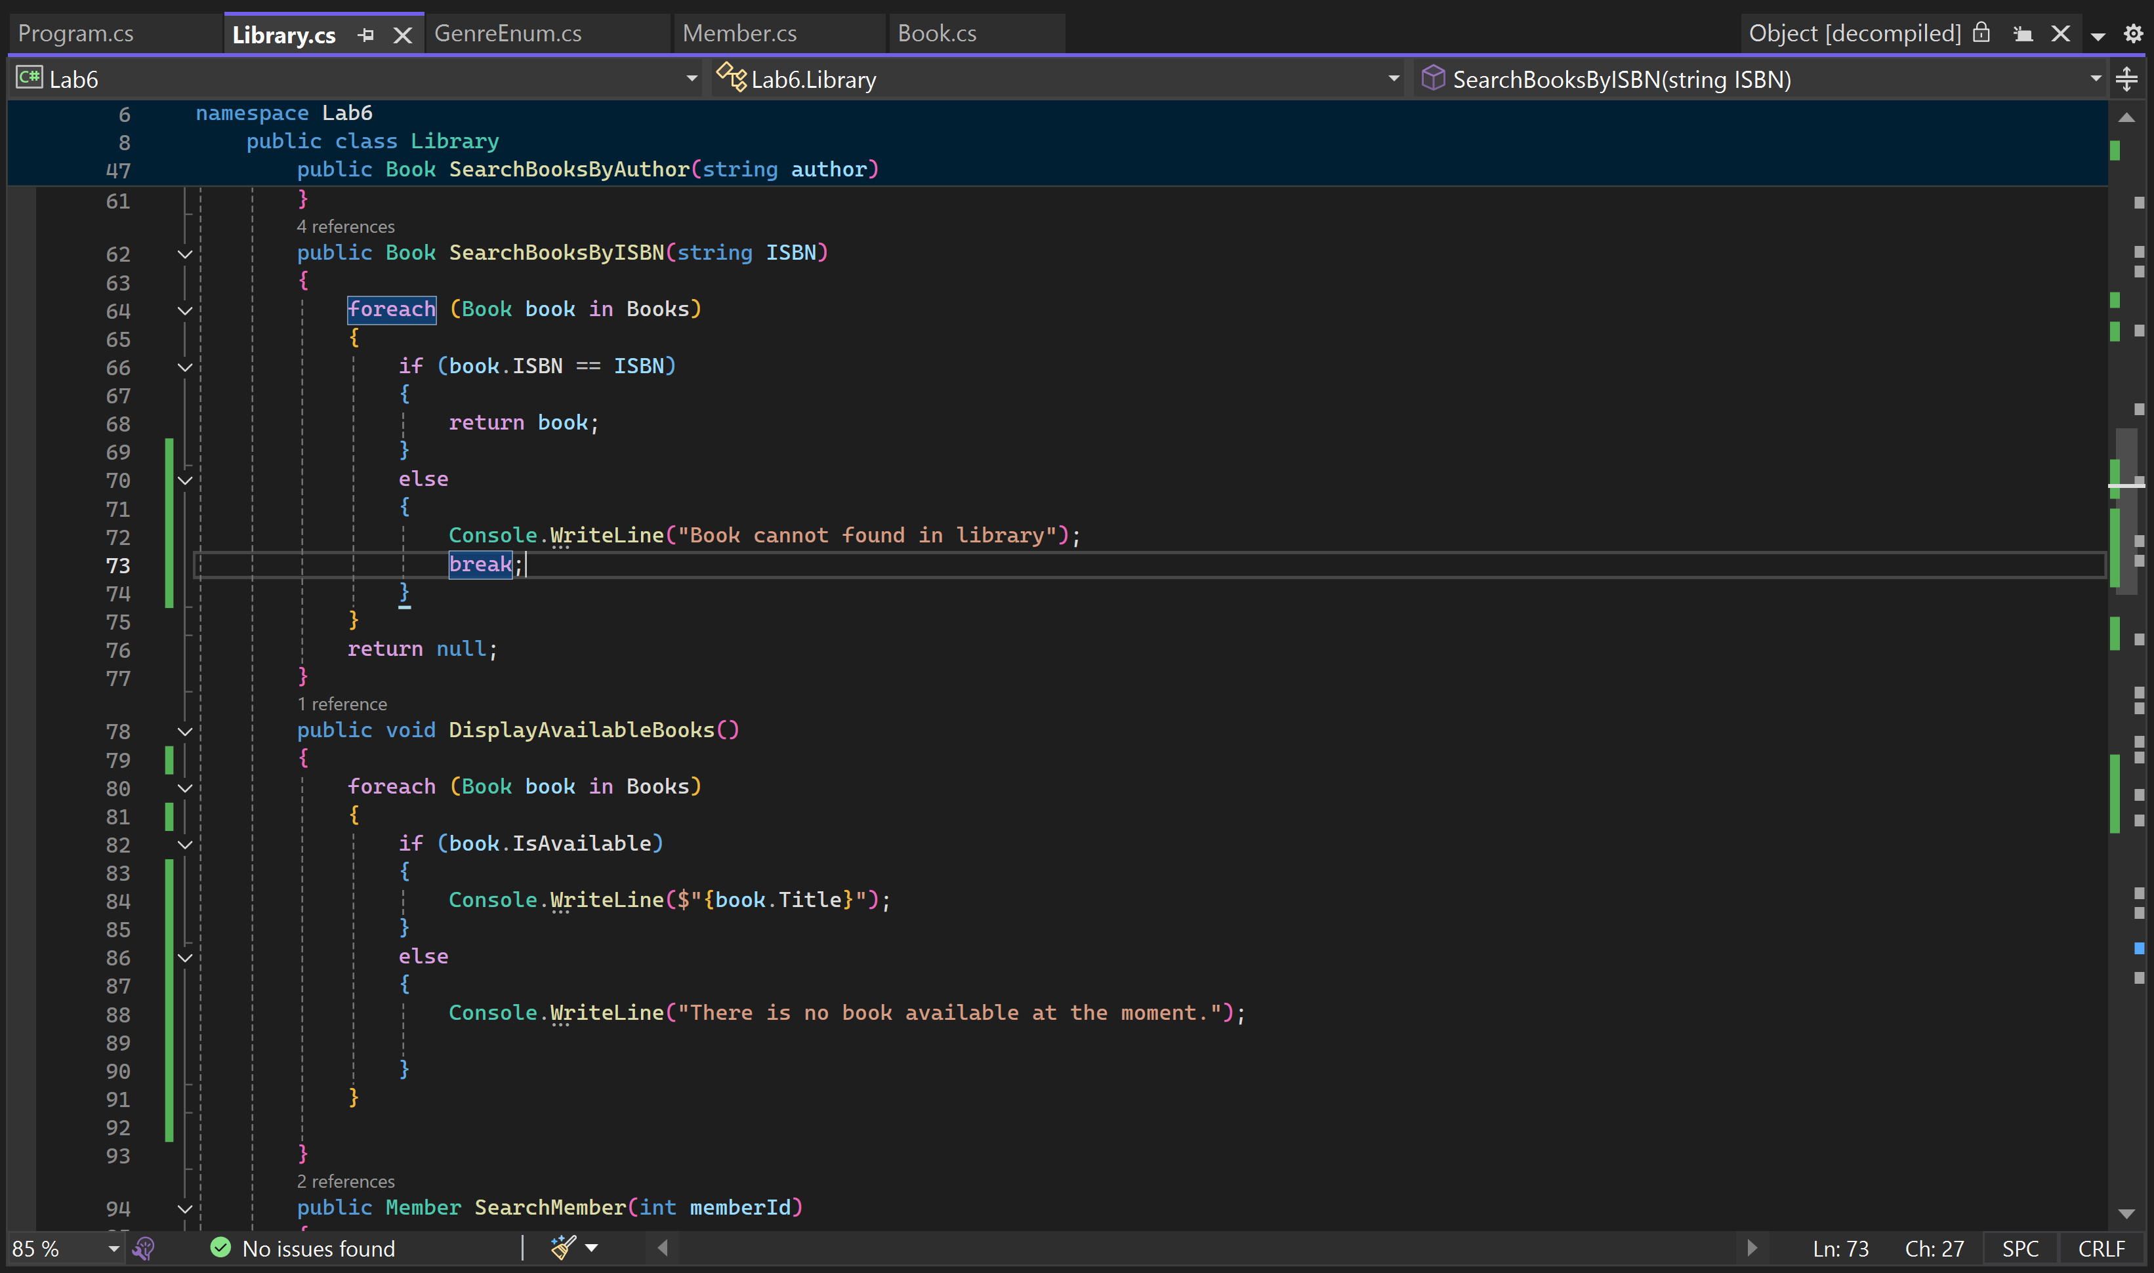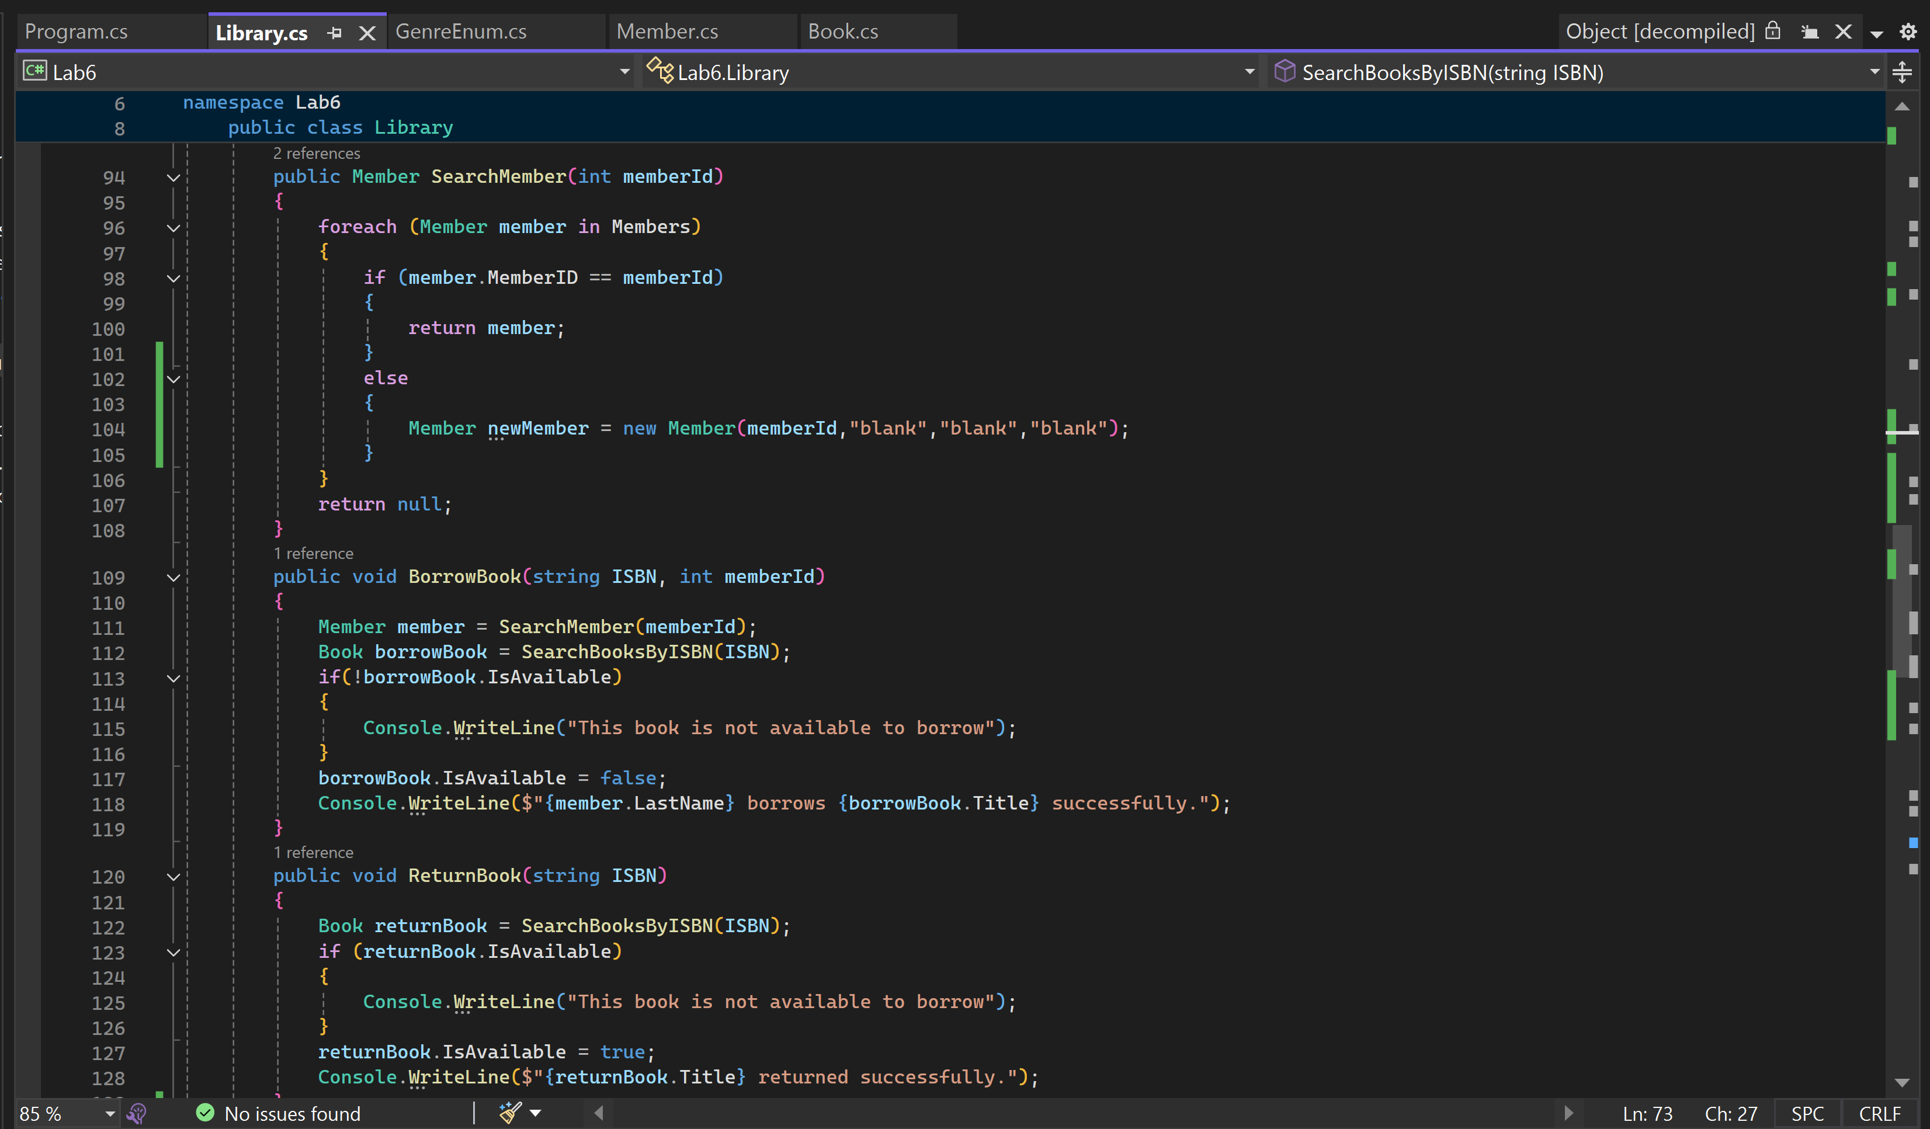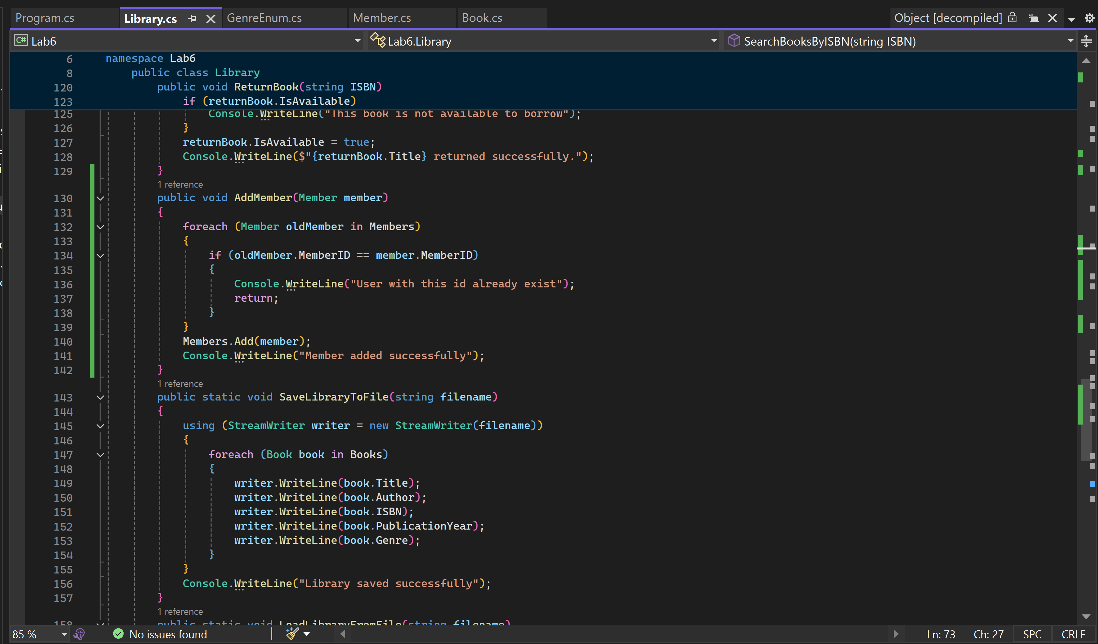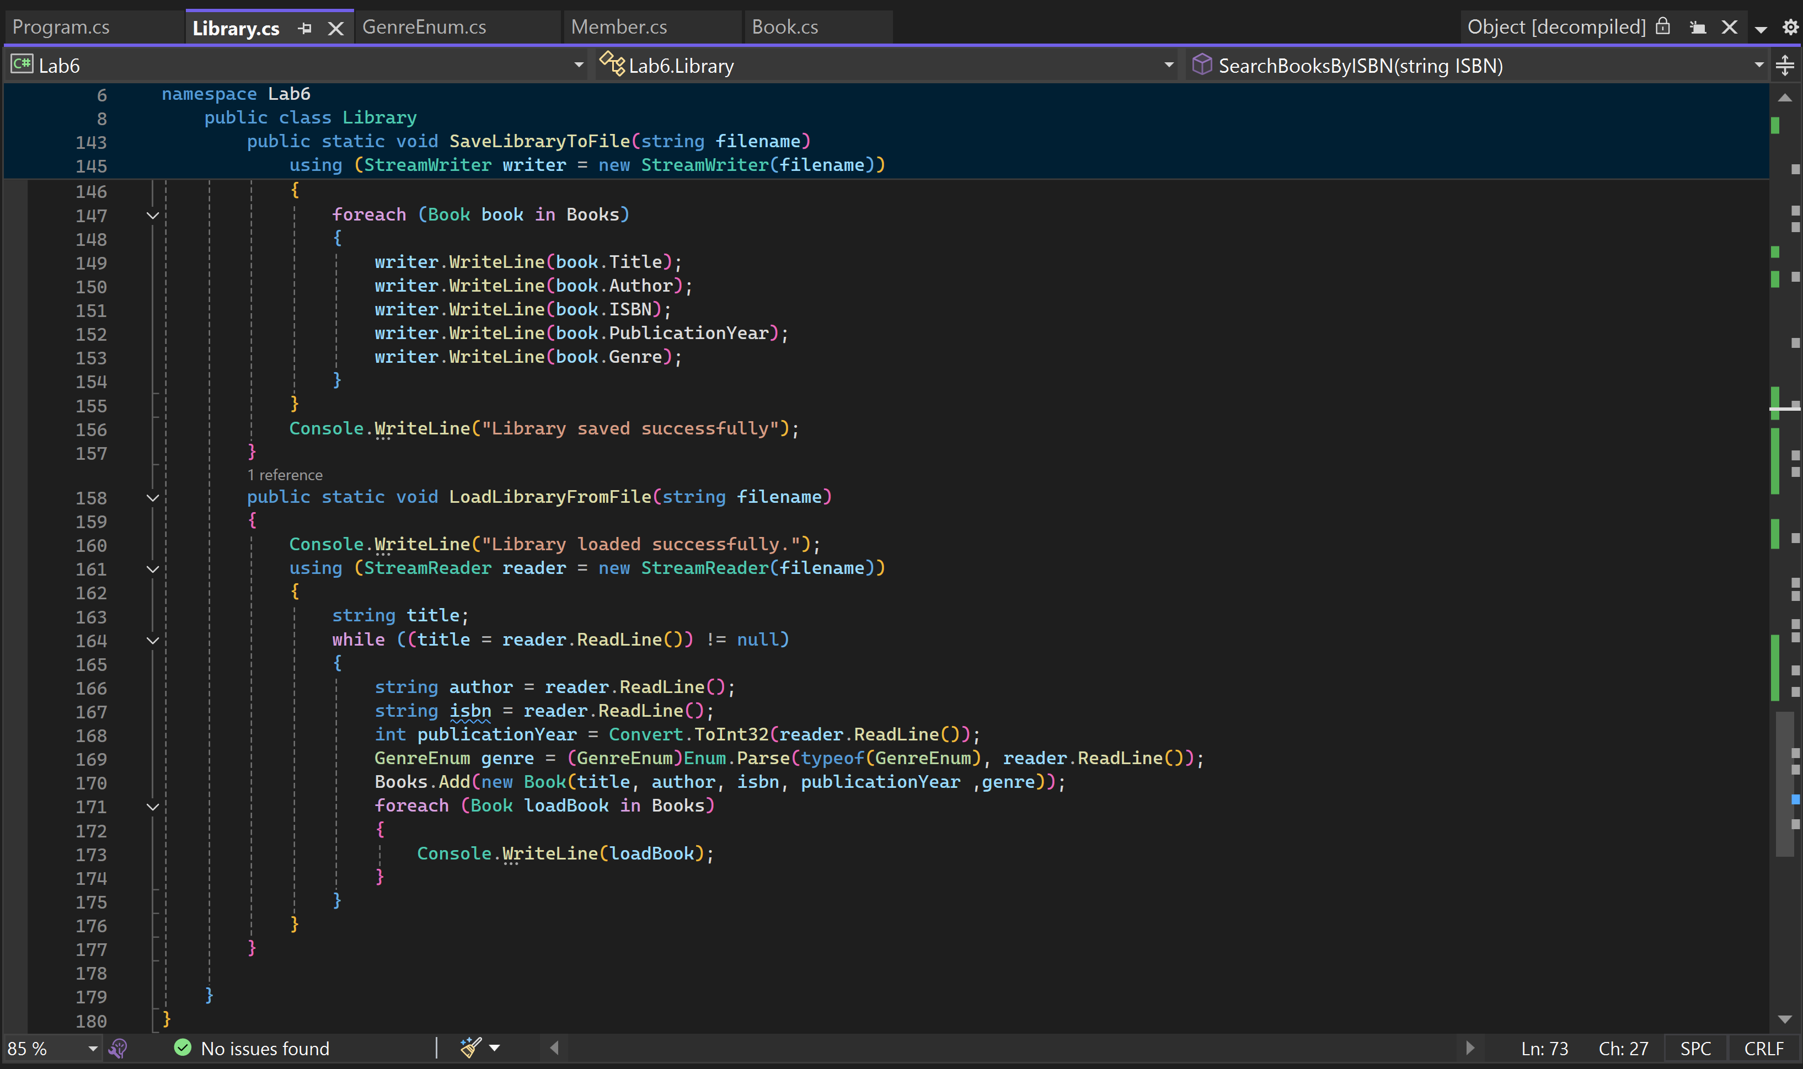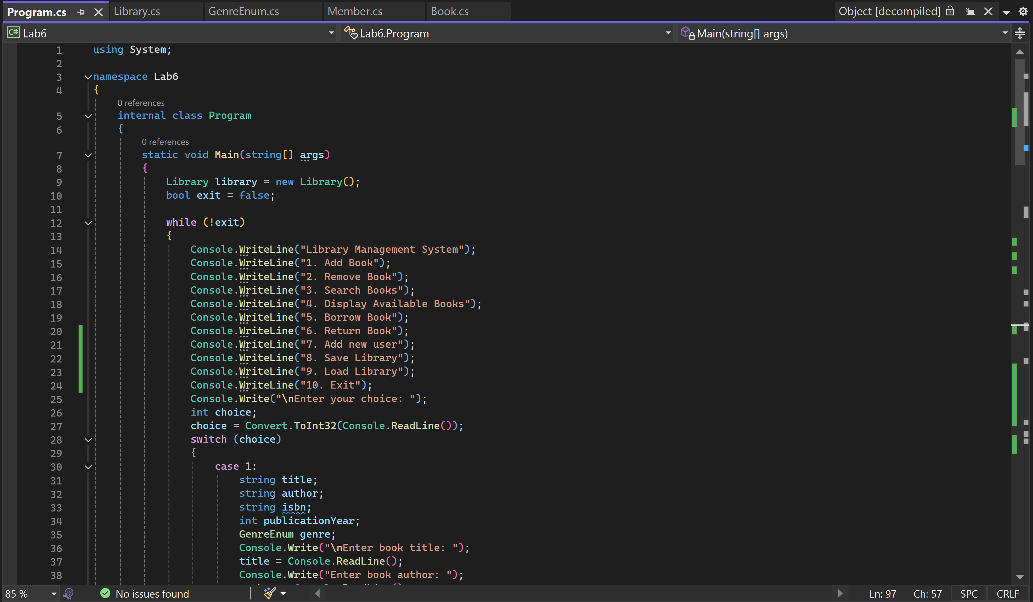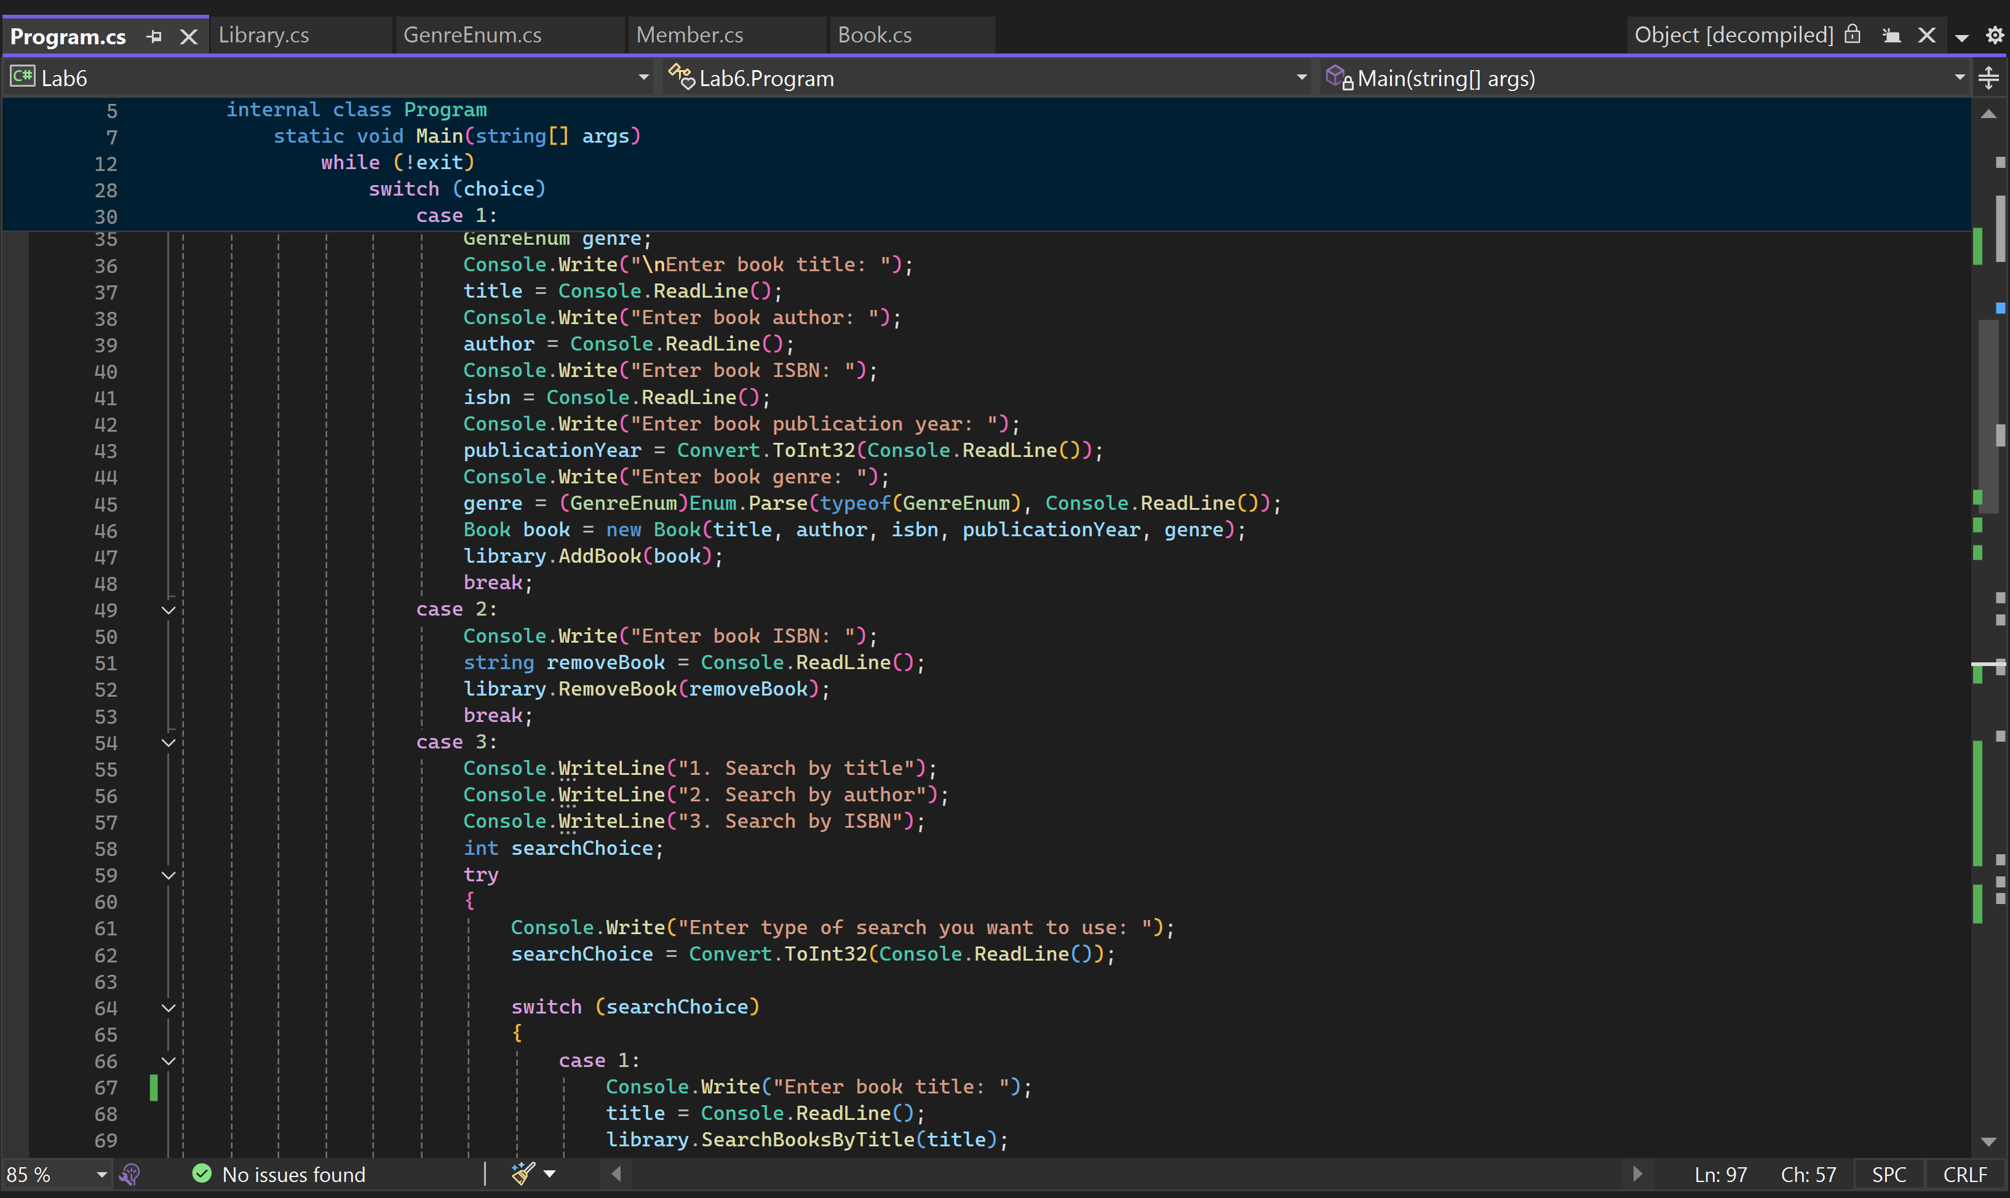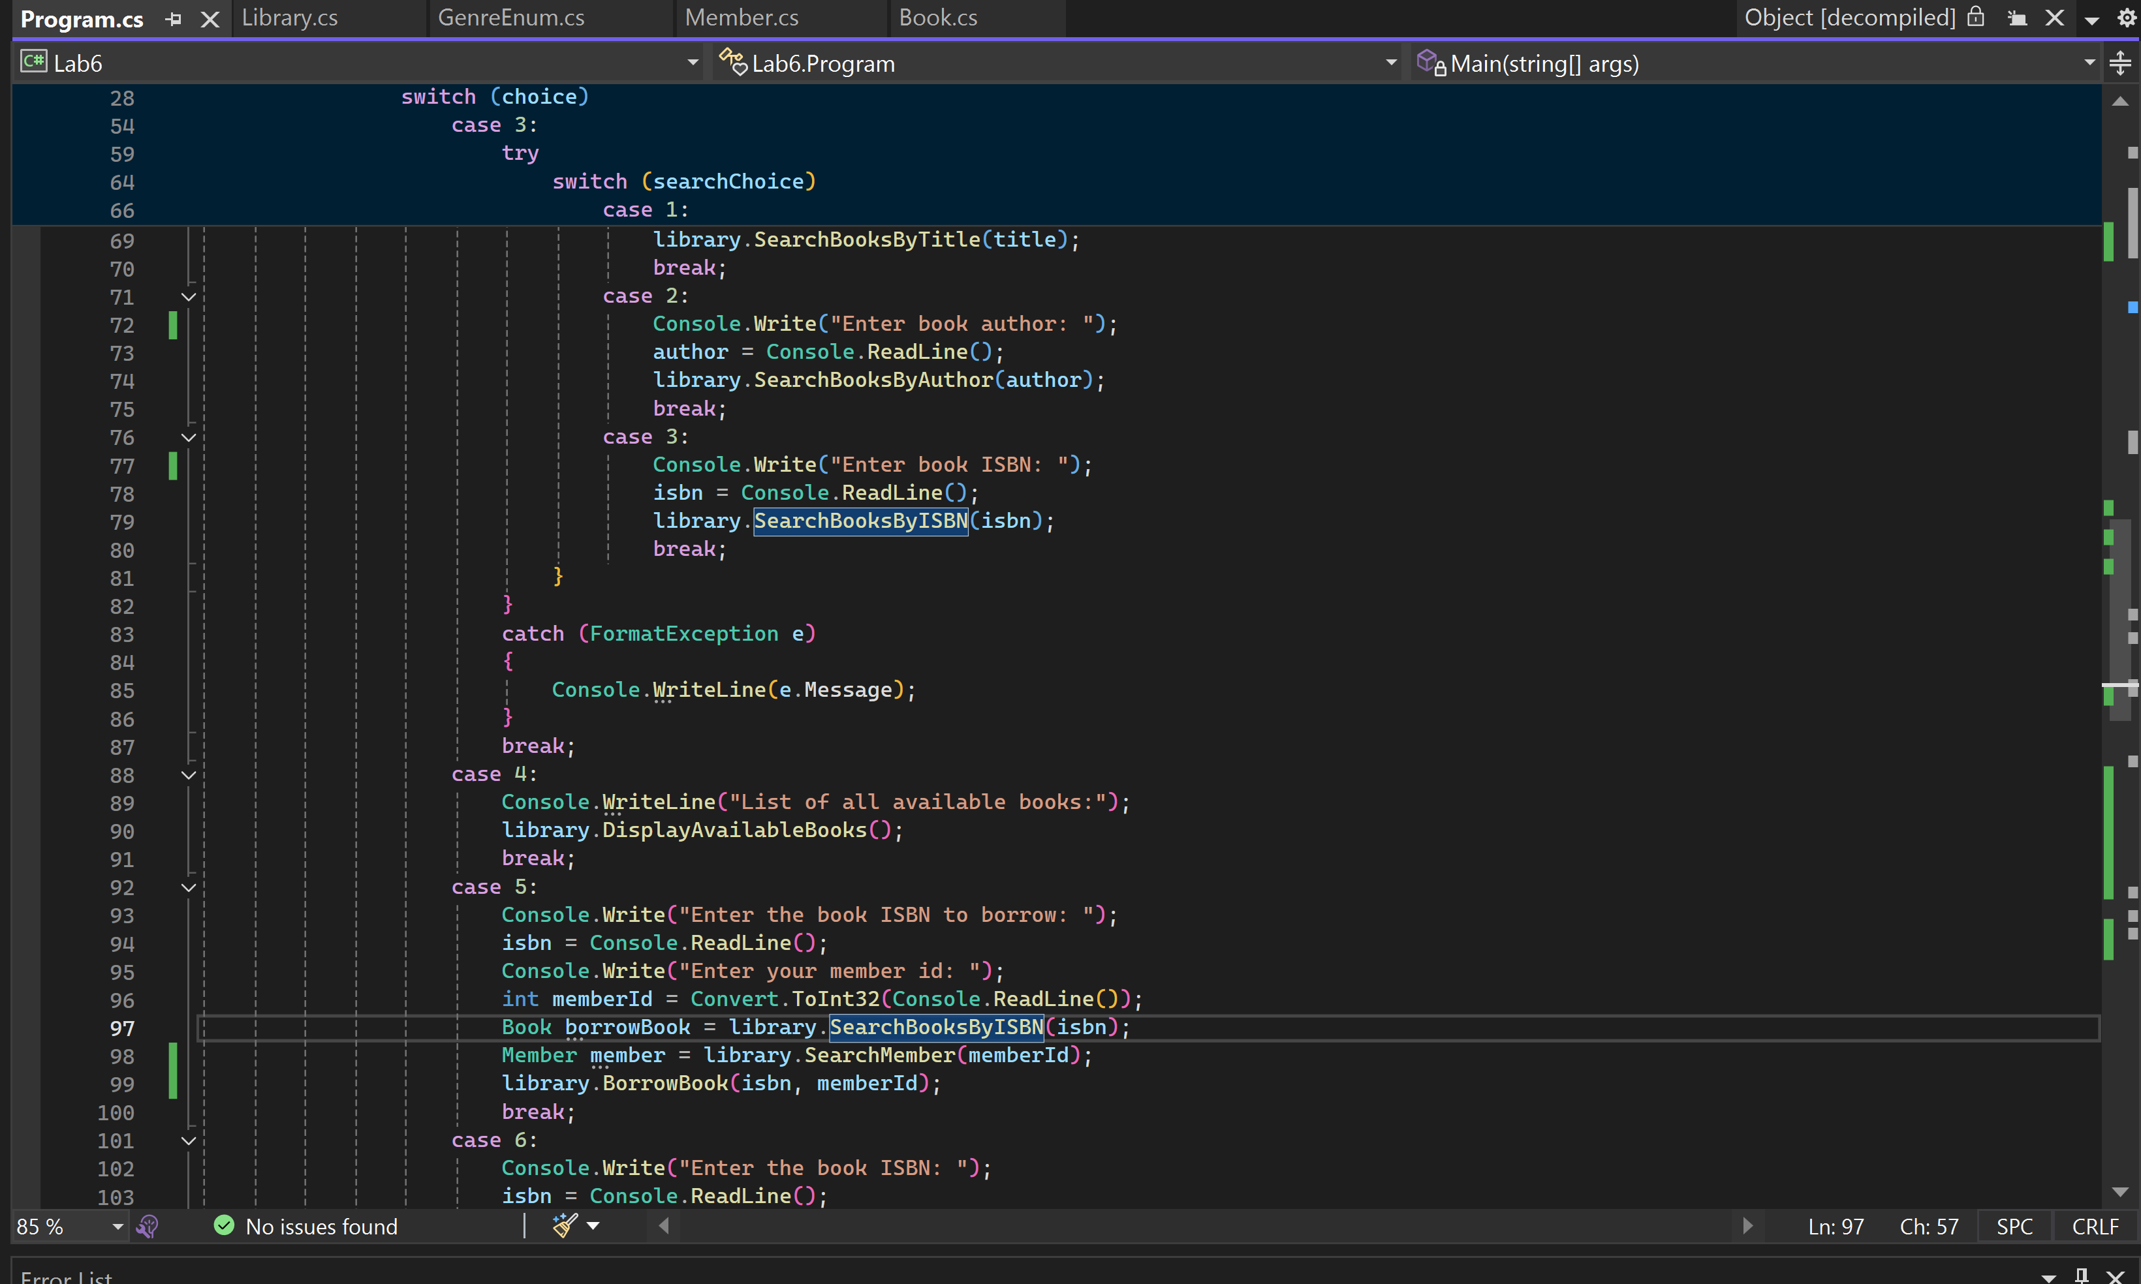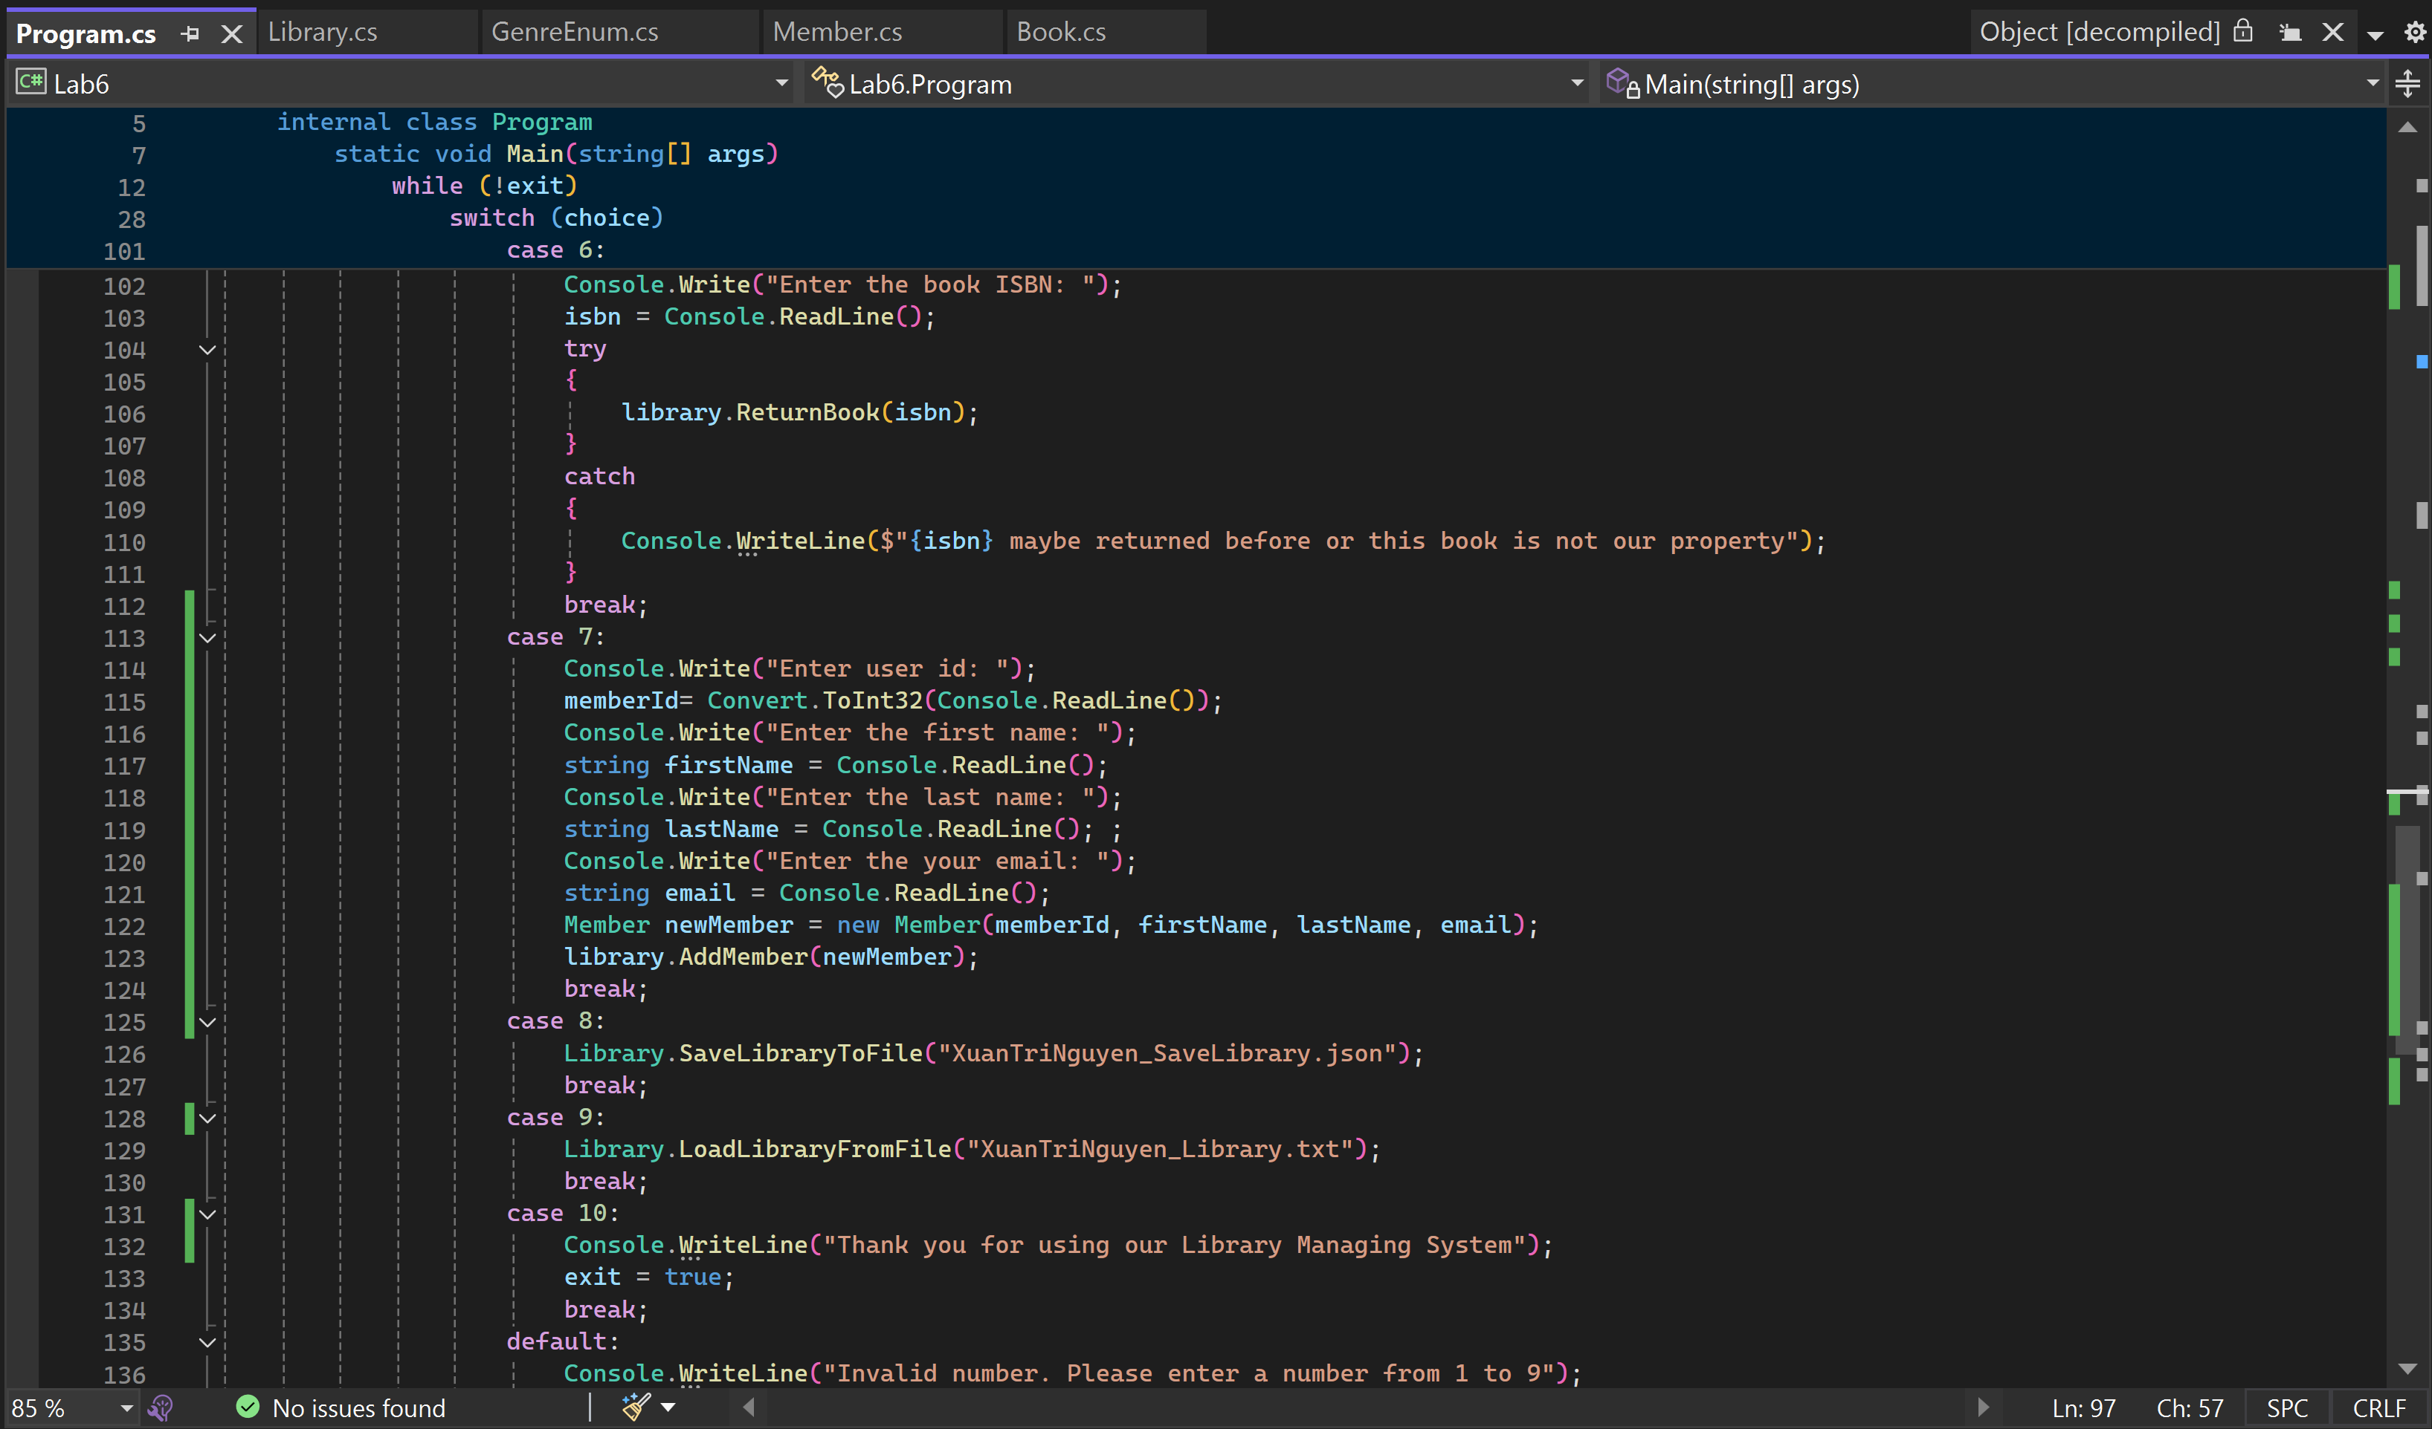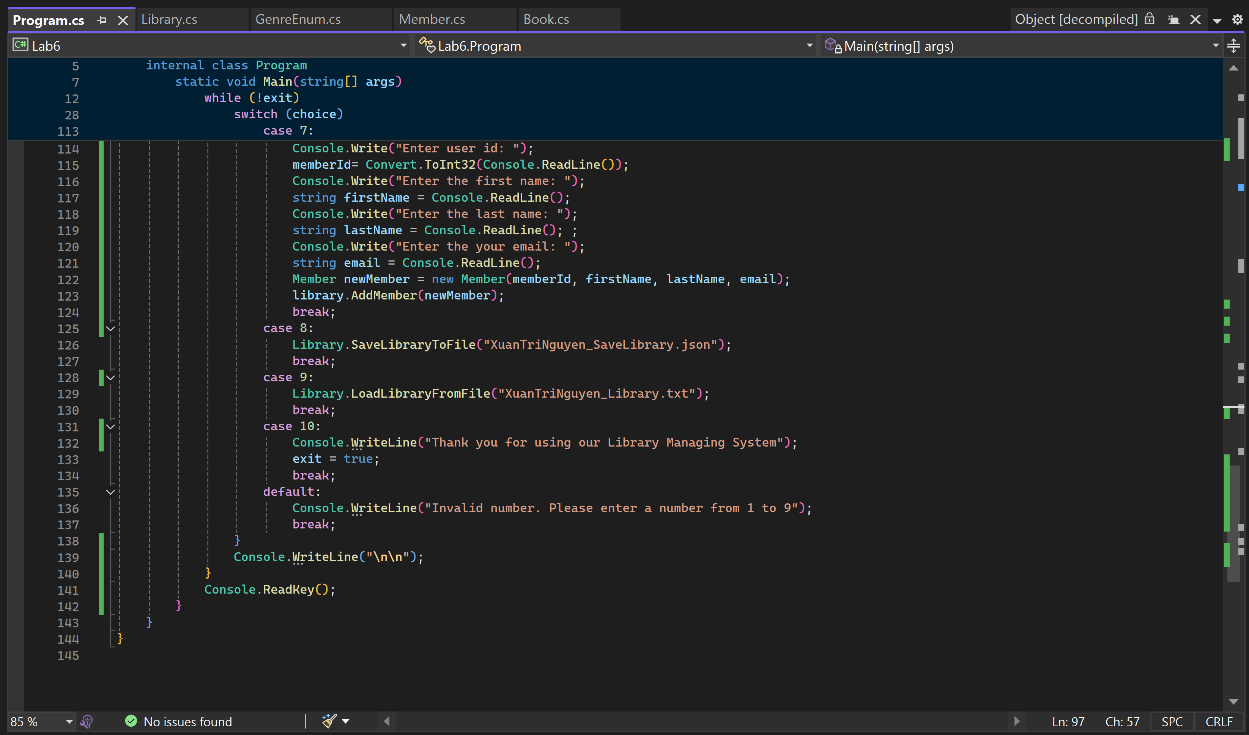

Results:

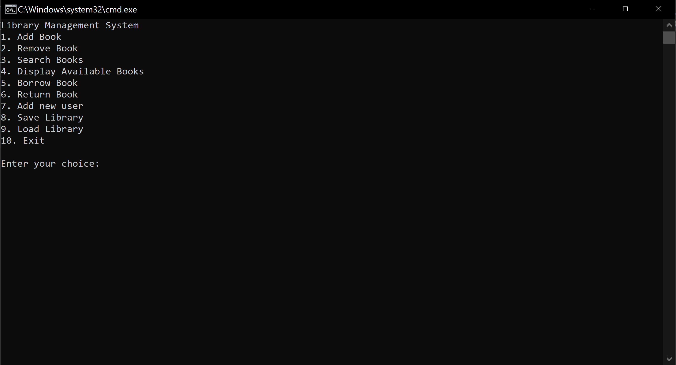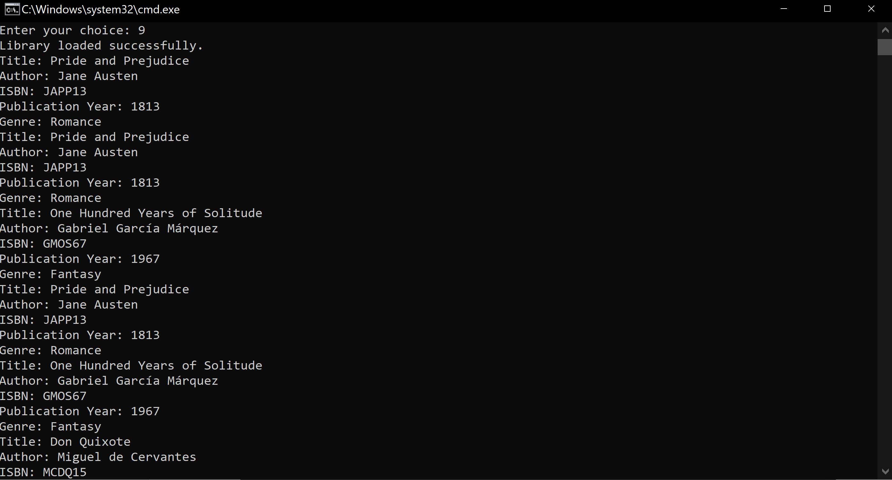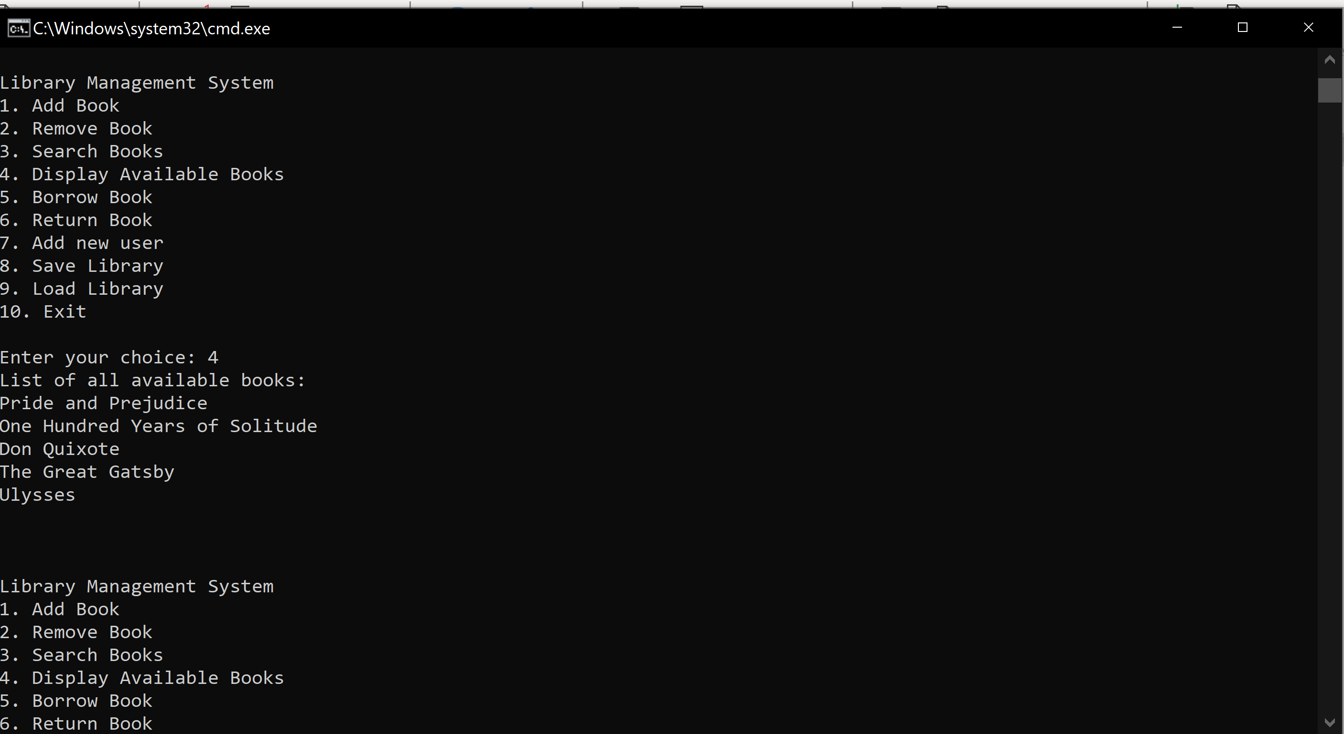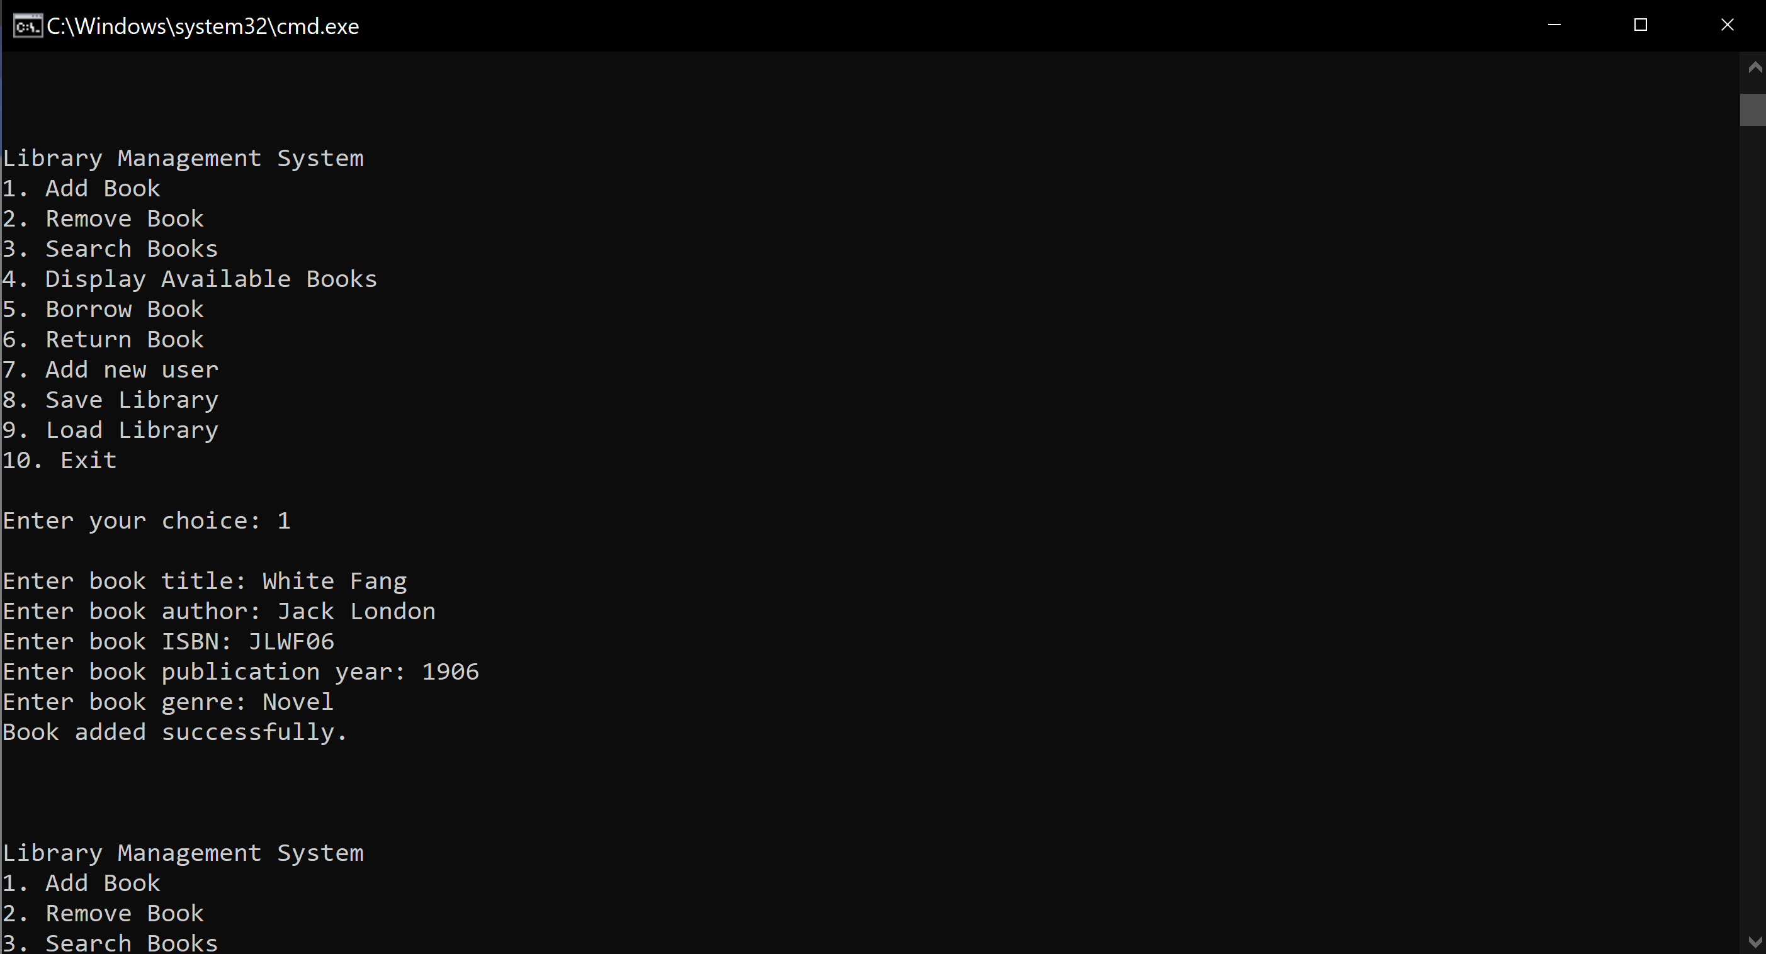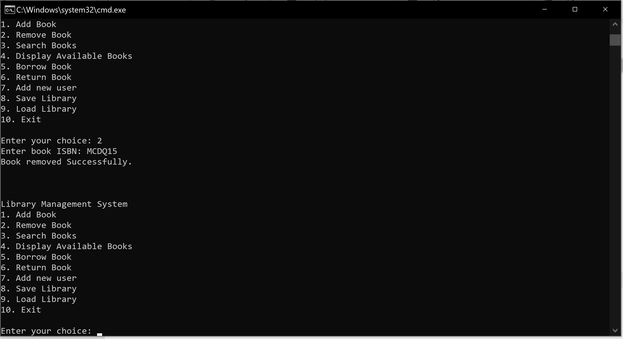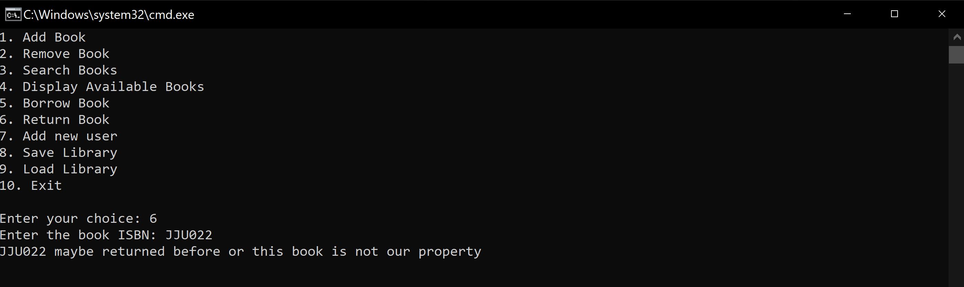

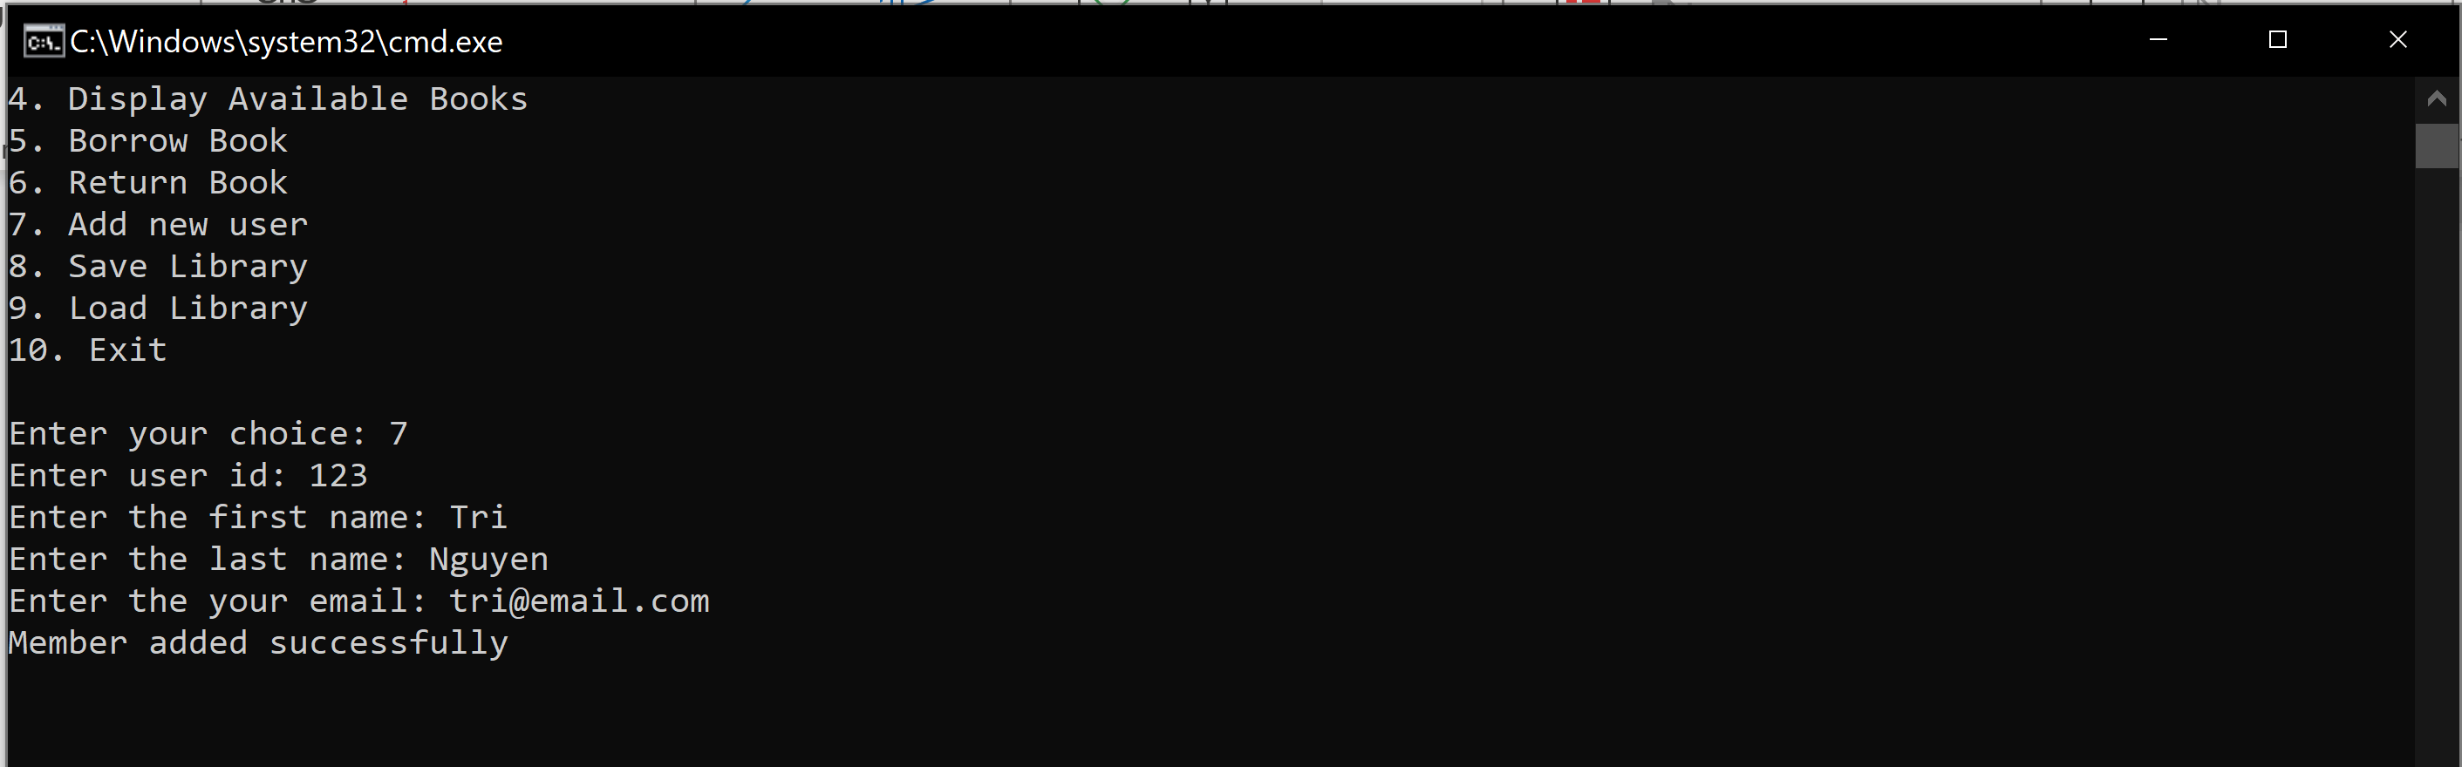

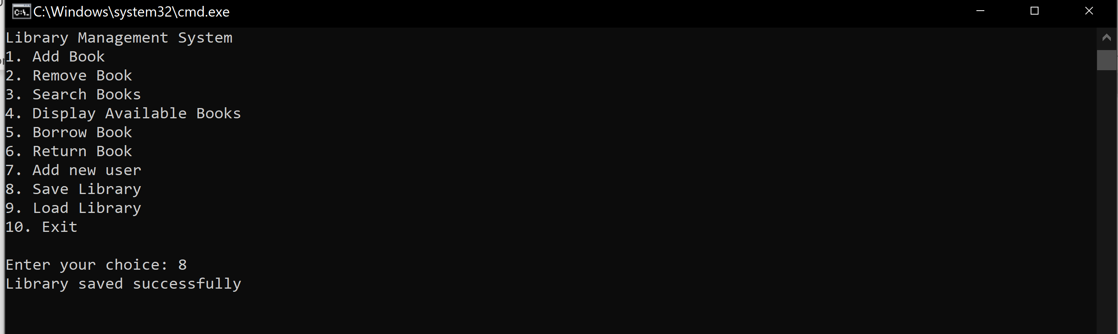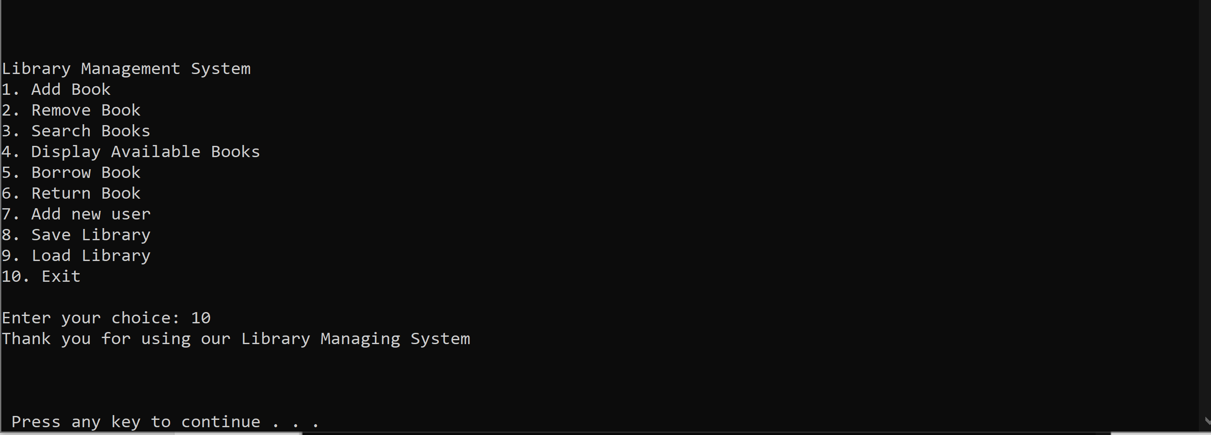

Code text:

using System;

using System.Collections.Generic;

using System.Linq;

using System.Text;

using System.Threading.Tasks;

namespace Lab6

{

[Flags]

public enum GenreEnum

{

Fiction,

NonFiction,

Fantasy,

ScienceFiction,

Mystery,

Thriller,

Romance,

HistoricalFiction,

Biography,

SelfHelp,

Children,

Young,

Adult,

Dystopian,

Horror,

Crime,

Western,

Poetry,

Drama,

Science,

History,

Travel,

Cooking,

Art,

Music,

Sports,

WomenFiction,

ArtPhotography,

AutobiographyMemoir,

Essays,

FoodDrink,

HowToGuides,

HumanitiesSocialSciences,

Humor,

Parenting,

Philosophy,

ReligionSpirituality,

ScienceTechnology,

TrueCrime,

Novel

}

}

using System;

using System.Collections.Generic;

using System.Linq;

using System.Text;

using System.Threading.Tasks;

using System.Xml.Linq;

namespace Lab6

{

public class Member

{

public int MemberID { get; set; }

public string FirstName { get; set; }

public string LastName { get; set; }

public string ContactInfo { get; set; }

public Member(int id, string firstName, string lastName, string contactInfo)

{

MemberID = id;

FirstName = firstName;

LastName = lastName;

ContactInfo = contactInfo;

}

public override string ToString()

{

return $"Member ID: {MemberID}\nName: {FirstName} {LastName}\nContact info: {ContactInfo}";

}

}

}

using System;

using System.Collections.Generic;

using System.Linq;

using System.Text;

using System.Threading.Tasks;

namespace Lab6

{

public class Book

{

public string Title { get; set; }

public string Author { get; set; }

public string ISBN { get; set; }

public int PublicationYear { get; set; }

public GenreEnum Genre { get; set; }

public bool IsAvailable { get; set; }

public Member Borrower { get; set; }

public DateTime DueDate { get; set; }

public Book(string title, string author, string isbn, int publicationYear, GenreEnum genre)

{

Title = title;

Author = author;

ISBN = isbn;

PublicationYear = publicationYear;

Genre = genre;

IsAvailable = true;

}

public override string ToString()

{

return $"Title: {Title}\nAuthor: {Author}\nISBN: {ISBN}\nPublication Year: {PublicationYear}\nGenre: {Genre}";

}

public bool Overdue()

{

return !IsAvailable && DueDate < DateTime.Now;

}

}

}

using System;

using System.Collections.Generic;

using System.IO;

using System.Linq.Expressions;

namespace Lab6

{

public class Library

{

private static List<Book> Books { get; set; } = new List<Book>();

public static List<Member> Members { get; set; } = new List<Member>();

public void AddBook(Book book)

{

Books.Add(book);

Console.WriteLine($"Book added successfully.");

}

public void RemoveBook(string ISBN)

{

foreach (Book book in Books)

{

if (ISBN == book.ISBN)

{

Books.Remove(book);

Console.WriteLine("Book removed Successfully.");

return;

}

}

Console.WriteLine("Book does not exist.");

}

public Book SearchBooksByTitle(string title)

{

foreach (Book book in Books)

{

if (title == book.Title)

{

book.ToString();

}

else

{

Console.WriteLine("Book cannot found in library");

break;

}

}

return null;

}

public Book SearchBooksByAuthor(string author)

{

foreach (Book book in Books)

{

if (book.Author == author)

{

book.ToString();

}

else

{

Console.WriteLine("Book cannot found in library");

}

}

return null;

}

public Book SearchBooksByISBN(string ISBN)

{

foreach (Book book in Books)

{

if (book.ISBN == ISBN)

{

return book;

}

else

{

Console.WriteLine("Book cannot found in library");

break;

}

}

return null;

}

public void DisplayAvailableBooks()

{

foreach (Book book in Books)

{

if (book.IsAvailable)

{

Console.WriteLine($"{book.Title}");

}

else

{

Console.WriteLine("There is no book available at the moment.");

}

}

}

public Member SearchMember(int memberId)

{

foreach (Member member in Members)

{

if (member.MemberID == memberId)

{

return member;

}

else

{

Member newMember = new Member(memberId,"blank","blank","blank");

}

}

return null;

}

public void BorrowBook(string ISBN, int memberId)

{

Member member = SearchMember(memberId);

Book borrowBook = SearchBooksByISBN(ISBN);

if(!borrowBook.IsAvailable)

{

Console.WriteLine("This book is not available to borrow");

}

borrowBook.IsAvailable = false;

Console.WriteLine($"{member.LastName} borrows {borrowBook.Title} successfully.");

}

public void ReturnBook(string ISBN)

{

Book returnBook = SearchBooksByISBN(ISBN);

if (returnBook.IsAvailable)

{

Console.WriteLine("This book is not available to borrow");

}

returnBook.IsAvailable = true;

Console.WriteLine($"{returnBook.Title} returned successfully.");

}

public void AddMember(Member member)

{

foreach (Member oldMember in Members)

{

if (oldMember.MemberID == member.MemberID)

{

Console.WriteLine("User with this id already exist");

return;

}

}

Members.Add(member);

Console.WriteLine("Member added successfully");

}

public static void SaveLibraryToFile(string filename)

{

using (StreamWriter writer = new StreamWriter(filename))

{

foreach (Book book in Books)

{

writer.WriteLine(book.Title);

writer.WriteLine(book.Author);

writer.WriteLine(book.ISBN);

writer.WriteLine(book.PublicationYear);

writer.WriteLine(book.Genre);

}

}

Console.WriteLine("Library saved successfully");

}

public static void LoadLibraryFromFile(string filename)

{

Console.WriteLine("Library loaded successfully.");

using (StreamReader reader = new StreamReader(filename))

{

string title;

while ((title = reader.ReadLine()) != null)

{

string author = reader.ReadLine();

string isbn = reader.ReadLine();

int publicationYear = Convert.ToInt32(reader.ReadLine());

GenreEnum genre = (GenreEnum)Enum.Parse(typeof(GenreEnum), reader.ReadLine());

Books.Add(new Book(title, author, isbn, publicationYear ,genre));

foreach (Book loadBook in Books)

{

Console.WriteLine(loadBook);

}

}

}

}

}

}

using System;

namespace Lab6

{

internal class Program

{

static void Main(string[] args)

{

Library library = new Library();

bool exit = false;

while (!exit)

{

Console.WriteLine("Library Management System");

Console.WriteLine("1. Add Book");

Console.WriteLine("2. Remove Book");

Console.WriteLine("3. Search Books");

Console.WriteLine("4. Display Available Books");

Console.WriteLine("5. Borrow Book");

Console.WriteLine("6. Return Book");

Console.WriteLine("7. Add new user");

Console.WriteLine("8. Save Library");

Console.WriteLine("9. Load Library");

Console.WriteLine("10. Exit");

Console.Write("\nEnter your choice: ");

int choice;

choice = Convert.ToInt32(Console.ReadLine());

switch (choice)

{

case 1:

string title;

string author;

string isbn;

int publicationYear;

GenreEnum genre;

Console.Write("\nEnter book title: ");

title = Console.ReadLine();

Console.Write("Enter book author: ");

author = Console.ReadLine();

Console.Write("Enter book ISBN: ");

isbn = Console.ReadLine();

Console.Write("Enter book publication year: ");

publicationYear = Convert.ToInt32(Console.ReadLine());

Console.Write("Enter book genre: ");

genre = (GenreEnum)Enum.Parse(typeof(GenreEnum), Console.ReadLine());

Book book = new Book(title, author, isbn, publicationYear, genre);

library.AddBook(book);

break;

case 2:

Console.Write("Enter book ISBN: ");

string removeBook = Console.ReadLine();

library.RemoveBook(removeBook);

break;

case 3:

Console.WriteLine("1. Search by title");

Console.WriteLine("2. Search by author");

Console.WriteLine("3. Search by ISBN");

int searchChoice;

try

{

Console.Write("Enter type of search you want to use: ");

searchChoice = Convert.ToInt32(Console.ReadLine());

switch (searchChoice)

{

case 1:

Console.Write("Enter book title: ");

title = Console.ReadLine();

library.SearchBooksByTitle(title);

break;

case 2:

Console.Write("Enter book author: ");

author = Console.ReadLine();

library.SearchBooksByAuthor(author);

break;

case 3:

Console.Write("Enter book ISBN: ");

isbn = Console.ReadLine();

library.SearchBooksByISBN(isbn);

break;

}

}

catch (FormatException e)

{

Console.WriteLine(e.Message);

}

break;

case 4:

Console.WriteLine("List of all available books:");

library.DisplayAvailableBooks();

break;

case 5:

Console.Write("Enter the book ISBN to borrow: ");

isbn = Console.ReadLine();

Console.Write("Enter your member id: ");

int memberId = Convert.ToInt32(Console.ReadLine());

Book borrowBook = library.SearchBooksByISBN(isbn);

Member member = library.SearchMember(memberId);

library.BorrowBook(isbn, memberId);

break;

case 6:

Console.Write("Enter the book ISBN: ");

isbn = Console.ReadLine();

try

{

library.ReturnBook(isbn);

}

catch

{

Console.WriteLine($"{isbn} maybe returned before or this book is not our property");

}

break;

case 7:

Console.Write("Enter user id: ");

memberId= Convert.ToInt32(Console.ReadLine());

Console.Write("Enter the first name: ");

string firstName = Console.ReadLine();

Console.Write("Enter the last name: ");

string lastName = Console.ReadLine(); ;

Console.Write("Enter the your email: ");

string email = Console.ReadLine();

Member newMember = new Member(memberId, firstName, lastName, email);

library.AddMember(newMember);

break;

case 8:

Library.SaveLibraryToFile("XuanTriNguyen_SaveLibrary.json");

break;

case 9:

Library.LoadLibraryFromFile("XuanTriNguyen_Library.txt");

break;

case 10:

Console.WriteLine("Thank you for using our Library Managing System");

exit = true;

break;

default:

Console.WriteLine("Invalid number. Please enter a number from 1 to 9");

break;

}

Console.WriteLine("\n\n");

}

Console.ReadKey();

}

}

}